BIG GAME CENSUS REPORT

The **Big Game Census** dashboard combines player demographics, geographical insights, and comparative data visualizations to offer a comprehensive look at players from various teams. The combination of metrics such as age, weight, and geographical origin provides users with an interactive way to explore trends in player data. The integration of census links further deepens the available information, allowing users to explore beyond the surface-level metrics.

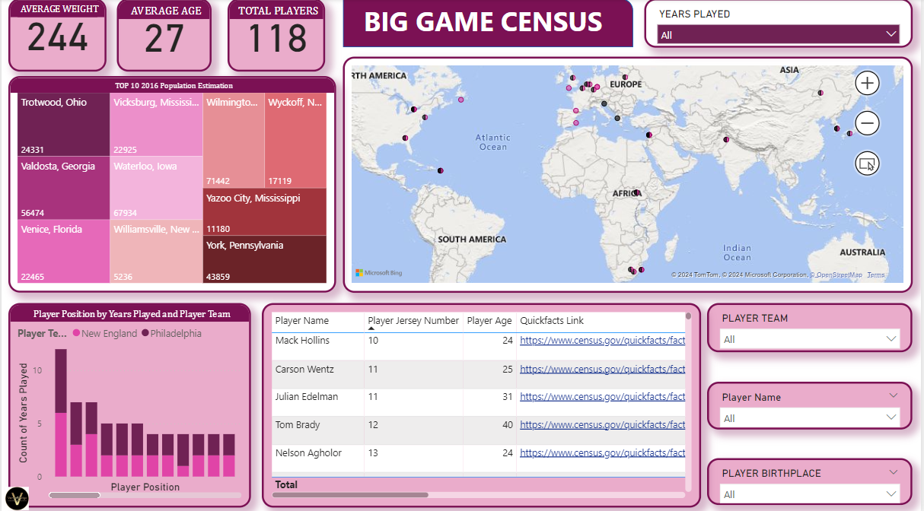

**KEY METRICS DISPLAY:**

**1.Average Weight (244 lbs):** This highlights the average weight of all the players included in the census.

**2.Average Age (27 years):** This metric shows the mean age of the player dataset.

**3.Total Players (118):** The number of players being analyzed or listed in this census.

**GEOGRAPHICAL DISTRIBUTION:**

The map in the center provides a global visualization of the players' birthplaces or associated locations. Each purple dot likely represents a player's place of birth or a significant location related to the player (like the city of origin). The locations span multiple continents, highlighting the global nature of the dataset.

**POPULATION ESTIMATIONS:**

**On the left-hand side, a treemap presents the top 10 cities from the 2016 population estimation. These cities include:**

* **Trotwood, Ohio (24,331)**
* **Vicksburg, Mississippi (22,925)**
* **Wilmington, Iowa (71,442)**
* **Valdosta, Georgia (56,474)**
* **Yazoo City, Mississippi (17,119)**
* **Venice, Florida (22,465)**

**This data provides insight into the hometowns of the players or other related demographics, but it is unclear if this population data correlates directly with the players' origins.**

**INTERACTIVITY:**

**The map, bar chart, and filters suggest a highly interactive dashboard where users can select specific teams, names, or positions and observe corresponding changes in the visualized data. This allows for detailed player-specific or team-specific analysis.**

**PLAYER POSITION & TEAM ANALYSIS:**

**A bar graph at the bottom left visualizes the count of years played for players from two teams: New England and Philadelphia. The data is segmented by position, offering a clear comparison of player longevity across the two teams. This visualization helps compare how long players from these teams have played in their respective positions.**